### National University of Computer & Emerging Sciences, Karachi Computer Science Department

| **Course Code: CL-1004** | **Course : Object Oriented Programming Lab** |
| --- | --- |

**Spring 2023, Lab Manual - 01**

# **Contents**

1. Introduction to IDE (Visual Studio 2022)
2. Skeleton of C++ program
3. Input/output in C++
4. Arrays
5. Pointers
6. Lab Tasks

# **INTRODUCTION TO IDE (VISUAL STUDIO 2022)**

Visual Studio is an Integrated Development Environment(IDE) developed by Microsoft to develop GUI (Graphical User Interface), console, Web applications, web apps, mobile apps, cloud, and web services, etc.

## **GETTING STARTED WITH VISUAL STUDIO 2020**

1. First, you have to download and install the Visual Studio. For that, you can refer to <https://visualstudio.microsoft.com/vs/> . Download the **Community 2022**.
2. After you installed the IDE, open the IDE and the following window will appear on your screen. Select Create new project.

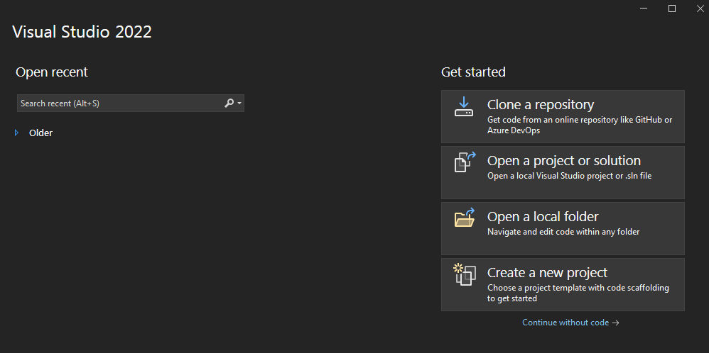

1. After creating a new project, create a C++ console application to write and run C++ programs.

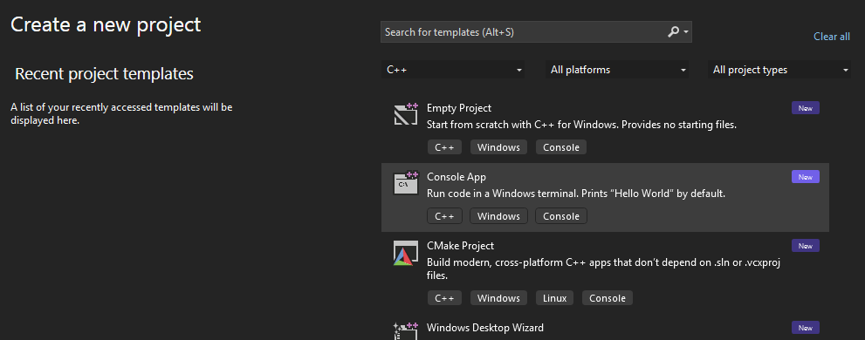

1. After creating a C++ file, you will get the following window.

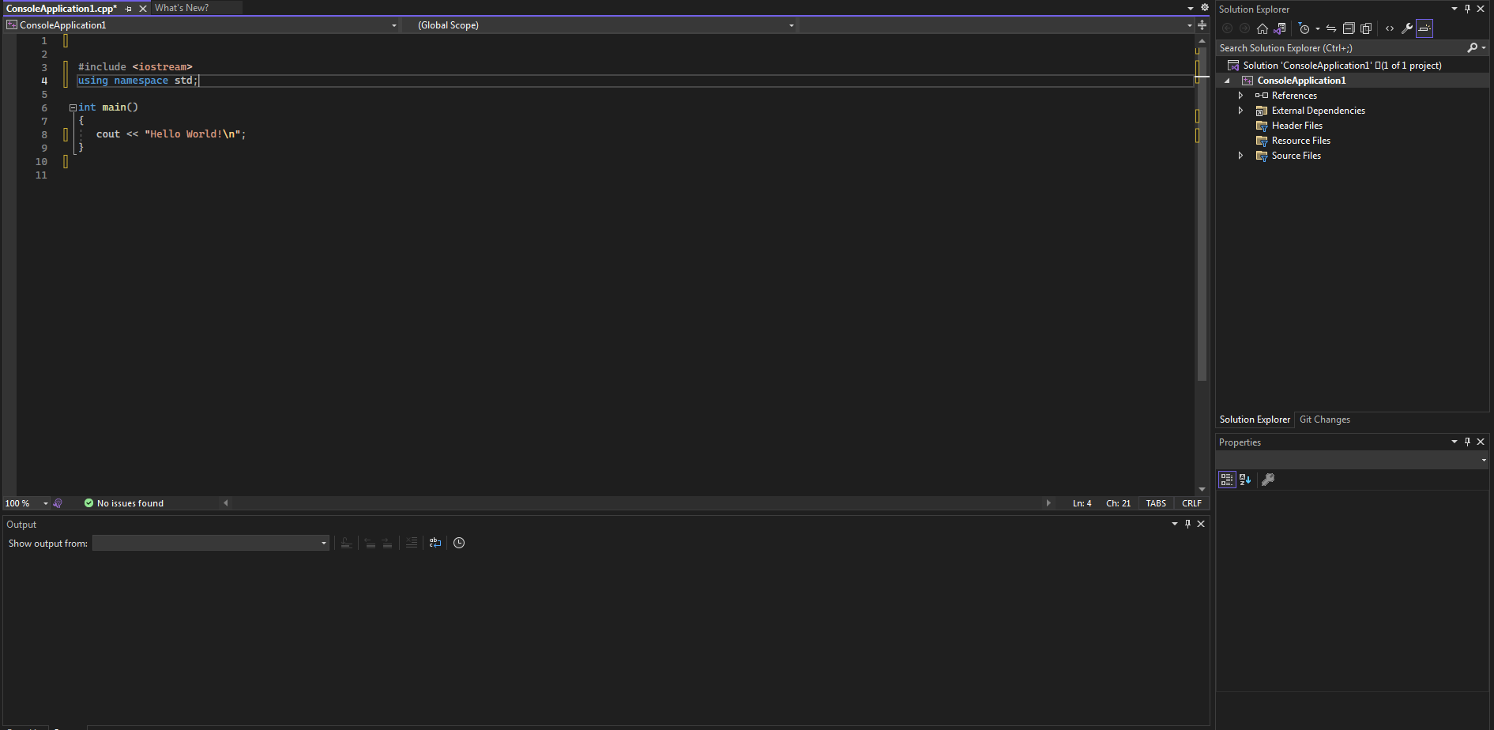

* **Code Editor**: Where the user will write code.
* **Output Window**: Here the Visual Studio shows the outputs, compiler warnings, error messages and debugging information.
* **Solution Explorer**: It shows the files on which the user is currently working.
* **Properties**: It will give additional information and context about the selected parts of the current project.

# **SKELETON OF C++ PROGRAM**

A C++ program is structured in a specific and particular manner. In C++, a program is divided into the following three sections:

1. Standard Libraries Section
2. Main Function Section
3. Function Body Section

For example, let’s look at the implementation of the Hello World program:

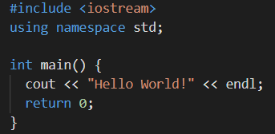

## **STANDARD LIBRARIES SECTION**



* #include is a specific preprocessor command that effectively copies and pastes the entire text of the file, specified between the angle brackets, into the source code.
* The file <iostream>, which is a standard file that should come with the C++ compiler, is short for input-output streams. This command contains code for displaying and getting an input from the user.
* namespace is a prefix that is applied to all the names in a certain set. iostream file defines two names used in this program - cout and endl.

## **MAIN FUNCTION SECTION**



* The starting point of all C++ programs is the main function.
* This function is called by the operating system when your program is executed by the computer.
* { signifies the start of a block of code, ​and } signifies the end.

# **INPUT/OUTPUT IN C++**

* C++ is very similar to the C Language.
* For the input/output stream we use <iostream> library (in C it was <stdio>).
* For taking input and out we cout and cin (in C it was printf and scanf).
* cout uses insertion ( << ) operator.
* cin uses extraction ( >> ) operator.

## **SAMPLE C++ CODE:**

#include <iostream>

using namespace std;

int main()

{

int var = 0;

cout << "Enter an Integer value: "; cin >> var;

cout << "Value of var is : " << var; return 0;

}

Sample Run: In this sample run, the user input is shaded. Enter an Integer value: 12

Value of var is : 12

# **ARRAYS**

An Array is a collection of fixed number of elements of same data type.

## **1-D ARRAY**

* 1-D Array is a form of array in which elements are arranged in a form of List.
* To declare a 1D array you need to specify the data type, name and array size.

**dataType arrayName [ arraySize ] ;**

* Following is the declaration of a 1D array.

**int numArray[5];**

where;

Data Type: Integers (int)

Array Name: numArray

Array Size: 5

* To access array elements, you use the array name along with the index in subscript operator **“[ ]”**.

**numArray[0], numArray[1], numArray[2], numArray[3], numArray[4]**

where;

Index of the array starts with zero ‘0’.

Index of the last element is always ‘size - 1’ (in this case it is 4).

## **Example Code for 1-D Array**

Program to read five numbers, find their sum, and print the numbers in reverse order.

#include <iostream>

using namespace std;

int main()

{

int item[5]; //Declare an array item of five components int sum = 0;

int counter;

cout << "Enter five numbers: ";

for (counter = 0; counter < 5; counter++)

{

cin >> item[counter];

sum = sum + item[counter];

}

cout << endl;

cout << "The sum of the numbers is: " << sum << endl; cout << "The numbers in reverse order are: ";

//Print the numbers in reverse order.

for (counter = 4; counter >= 0; counter--)

cout << item[counter] << " ";

cout << endl;

return 0;

}

**Sample Run**: In this sample run, the user input is shaded. Enter five numbers: 12 76 34 52 89

The sum of the numbers is: 263

The numbers in reverse order are: 89 52 34 76 12

## **2-D ARRAY**

1. 2-D Array is a collection of fixed collection of elements arranged in rows and columns.
2. To declare a 2D array you need to specify the data type, name and no. of rows and columns.

dataType arrayName [ rowSize ][ columnSize ] ;

1. Following is the declaration of a 2D array.

int numArray[5][5];

where;

* Data Type: Integers
* Array Name: numArray
* Rows: 5
* Columns: 5

1. To access array element you use the array name along with the row Index and column Index in subscript operator “[ ][ ]”.

numArray[0][0], numArray[1][1], numArray[2][2], numArray[3][3], numArray[4][4].

where;

* Index for the rows and columns of the array starts with zero ‘0’.
* Index of the last element in rows and columns is always **‘sizeofRow - 1’** and **‘sizeofColumn -1’** respectively (in this case it is 4).

## **Example Code for 2-D Array:**

Program to read a 2D array of size 3x3 find the sum for each row, print the sum line by line.

#include <iostream>

using namespace std;

int main()

{

int item[3][3]; //Declare an array of size 3x3 int sum = 0;

int row, col;

cout << "Enter array elements: " << endl;

for (row = 0; row < 3; row++)

{

for (col = 0; col < 3; col++)

{

cin >> item[row][col]; sum = sum + item[row][col];

}

cout << "The sum of row " << i << " : " << sum <<

endl;

}

cout << endl; return 0;

}

**Sample Run**: In this sample run, the user input is shaded. Enter array elements:

12 76 34

The sum of row 0 : 122 52 89 48

The sum of row 1 : 189 22 63 99

The sum of row 2 : 184

# **POINTERS**

A Pointer is a variable whose content is a memory address.

## **SINGLE POINTERS**

1. To declare a single pointer variable you need to specify the data type, an asterisk symbol ( * ) and the name of the pointer variable.

**dataType *ptrName;**

1. Following is the declaration of a Pointer variable.

**int *ptr;**

where;

* DataType: Integer
* Name: ptr

1. Pointer variable holds the memory address of the variable which is of same data type (integer in this case).
2. To assign the memory address of any variable to the pointer variable we use Address of Operator ( & ).

**int intVar = 5;**

**ptr = &intVar;**

In this statement ptr now holds the memory address of an integer variable ‘intVar’.

1. To access the value at the memory address (currently stored) in the variable we use Dereferencing Operator ( * ).
2. Do not confuse this with the symbol used for the declaration of a pointer.

**int intVar2 = *ptr;**

In this statement another integer variable ‘intVar2’ is now initialized with the value at the memory address which is stored in ptr (that is the value of intVar).

## **Example Code for Single Pointers**

The following program illustrates how pointer variables work:

#include <iostream>

using namespace std;

int main()

{

int *p;

int x = 37;

cout << "Line 1: x = " << x << endl; //Line 1 p = &x; //Line 2

//Line 3

cout << "Line 3: *p = " << *p << ", x = " << x << endl;

*p = 58; //Line 4

//Line 5

cout << "Line 5: *p = " << *p << ", x = " << x << endl; cout << "Line 6: Address of p = " << &p << endl; //Line 6 cout << "Line 7: Value of p = " << p << endl; //Line 7

cout << "Line 8: Value of the memory location " << "pointed to by *p = " << *p << endl; //Line 8

cout << "Line 9: Address of x = " << &x << endl; //Line 9 cout << "Line 10: Value of x = " << x << endl; //Line 10 return 0;

}

**Sample Run**:

Line 1: x = 37

Line 3: *p = 37, x = 37

Line 5: *p = 58, x = 58

Line 6: Address of p = 006BFDF4 Line 7: Value of p = 006BFDF0

Line 8: Value of the memory location pointed to by *p = 58 Line 9: Address of x = 006BFDF0

Line 10: Value of x = 58

## **DYNAMIC VARIABLES**

1. Variables created during the program execution are called dynamic variables.
2. To create a dynamic variable, we use new operator.

**new dataType [ size]; // to allocate an array of variables.**

where

* The new operator allocates the memory of a designated type.
* It returns a pointer to the allocated memory.

1. Following is the declaration of a dynamic variable.

**int p = new int;**

**char cArray = new char[5];**

where;

* Line 01: creates a single variable of integer type.
* Line 02: Creates an array of 5 characters.

1. To delete the dynamically allocated memory we use delete operator.

**delete ptrVar; //to deallocate single dynamic variable**

**delete [] ptrArray; //to deallocate dynamically created array**

1. delete operator is used to free the memory which is dynamically allocated using new operator.

## **Example Code for Dynamic Variables**

#include<iostream>

using namespace std;

int main()

{

int* intPtr;

char* charArray; int arraySize;

intPtr = new int; // allocating memory to single variable cout << "Enter an Integer Value: ";

cin >> *intPtr;

cout << "Enter the size of the Character Array : "; cin >> arraySize;

charArray = new char[arraySize]; // allocating memory to array

for (int i = 0; i < arraySize; i++)

cin >> charArray[i];

for (int i = 0; i < arraySize; i++)

cout << charArray[i];

return 0;

}

# **Lab Tasks**

1). Write a program that calculates the squares and cubes of the integers from 0 to 10.

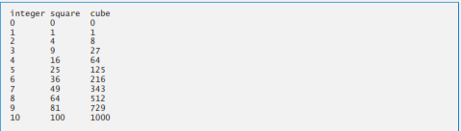

2). The formulas for calculating BMI are:

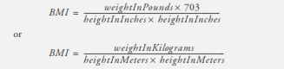

Create a BMI calculator application that reads the user’s weight in pounds and height in inches (or, if you prefer, the user’s weight in kilograms and height in meters), then calculates and displays the user’s body mass index. Also, the application should display the following information from the Department of Health and Human Services/National Institutes of Healths of the user can evaluate his/her BMI.

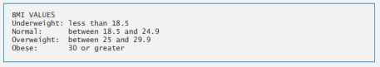

3). Use a one-dimensional array to solve the following problem:

Read in 20 numbers, each of which is between10 and 100, inclusive. As each number is read, validate it and store it in the array only if it isn’t a duplicate of a number already read. After reading all the values, display only the unique values that the user entered. Provide for the “worst case” in which all 20 numbers are different. Use the smallest possible array to solve this problem.

4). Write a function that takes a C string as an input parameter and reverses the string. The function should use two pointers, front and rear. The front pointer should initially reference the first character in the string, and the rear pointer should initially reference the last character in the string. Reverse the string by swapping the characters referenced by front and rear, then increment front to point to the next character and decrement rear to point to the preceding character, and so on, until the entire string is reversed. Write a main program to test your function on various strings of both even and odd length.

5). Write a program that simulates the rolling of two dice. The program should use rand to roll the first die and should use rand again to roll the second die. The sum of the two values should then be calculated. [Note: Each die can show an integer value from 1 to 6, so the sum of the two values will vary from 2 to 12, with 7 being the most frequent sum and 2 and 12 being the least frequent sums. Figure shows the 36 possible combinations of the two dice. Your program should roll the two dice 36 times. Use a one-dimensional array to tally the numbers of times each possible sum appears. Print the results in a tabular format.

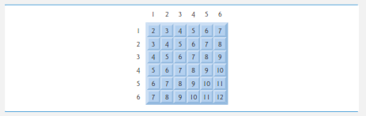

6). Write a function named out_of_order that takes as parameters an array of double s and an int parameter named size and returns a value of type int. This function will test this array for being out of order, meaning that the array violates the following condition:

a[0] <= a[1] <= a[2] <= ...

The function returns −1 if the elements are not out of order; otherwise, it will return the index of the first element of the array that is out of order.

For example, consider the declaration

double a[10] = {1.2, 2.1, 3.3, 2.5, 4.5,

7.9, 5.4, 8.7, 9.9, 1.0};

In this array, a[2] and a[3] are the first pair out of order, and a[3] is the first element out of order, so the function returns 3. If the array were sorted, the function would return −1.